SAMSUNG

**Website :** <https://www.samsung.com/us/>

**Note : Please add your feedback in red colour. Thank you**

**#01 - Free standing Stainless Steel | DW60R2014US**

* **Using the model name as the search term**

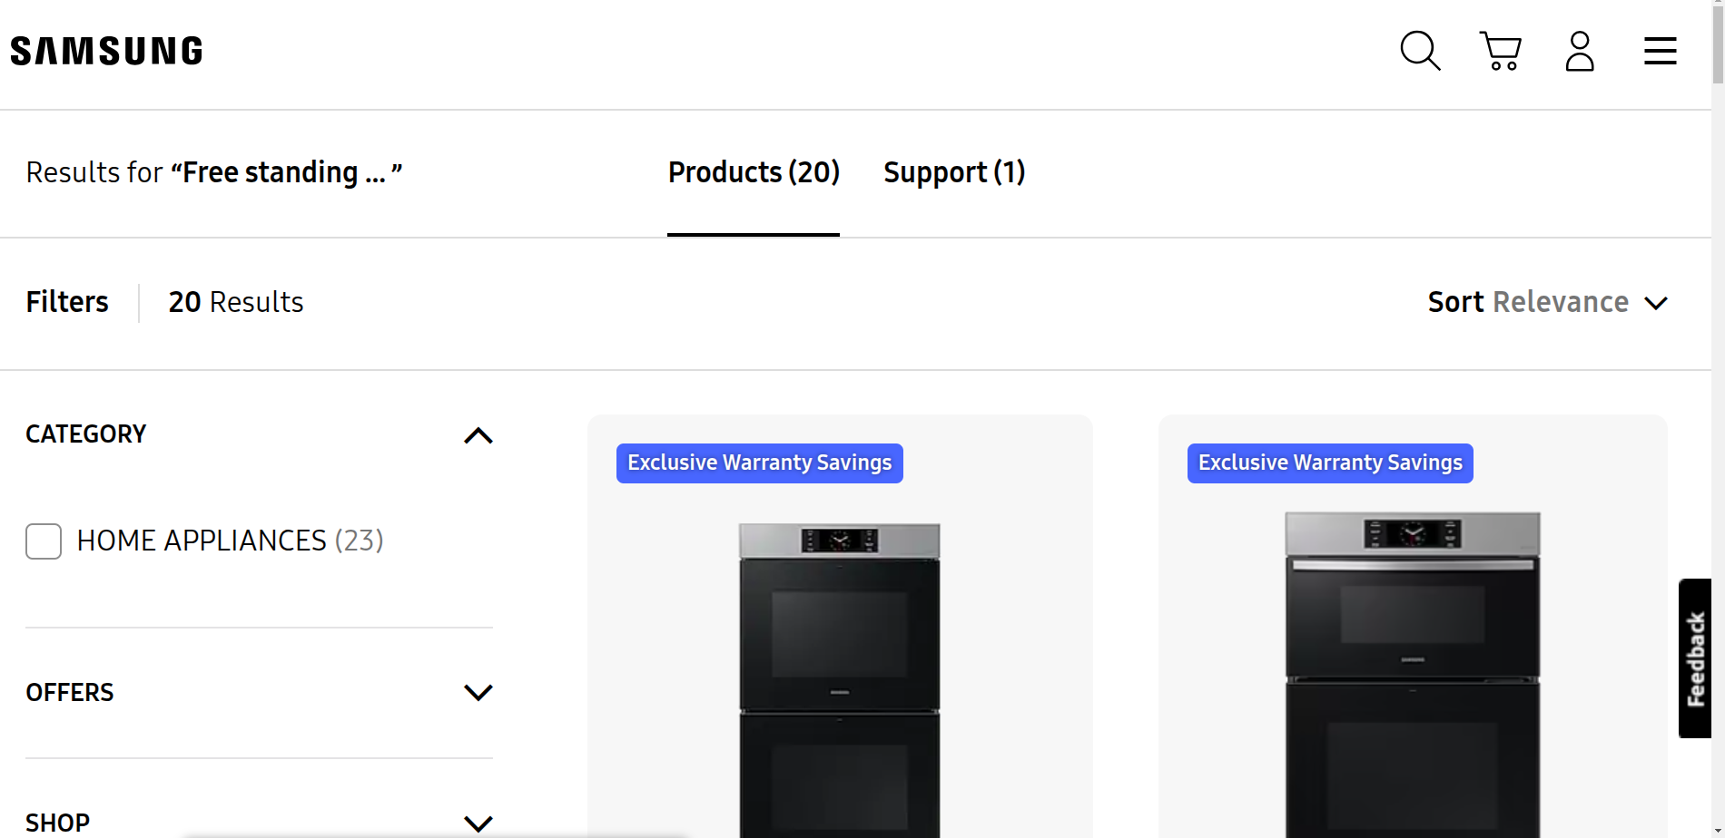

**Result:**

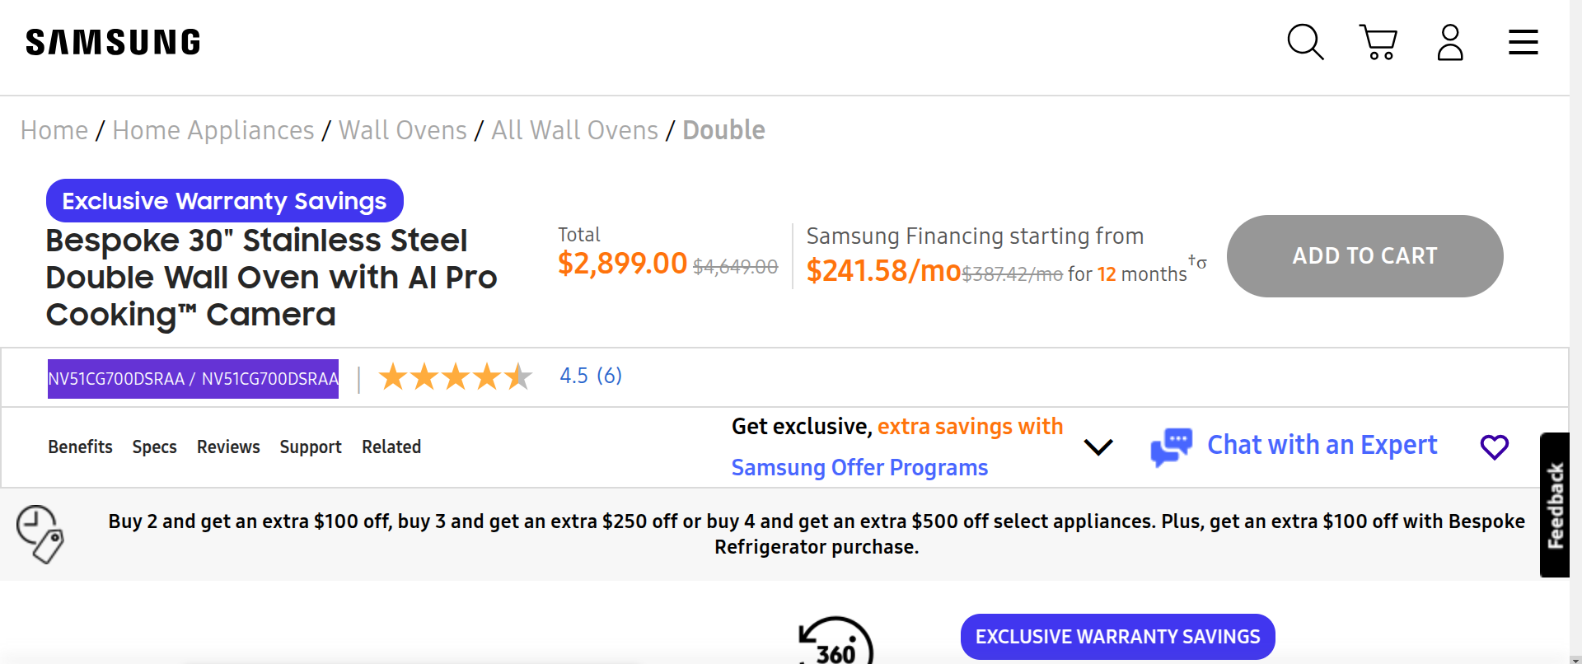

**Note: The mfr number is different**

* **Using the mfr number as search term**

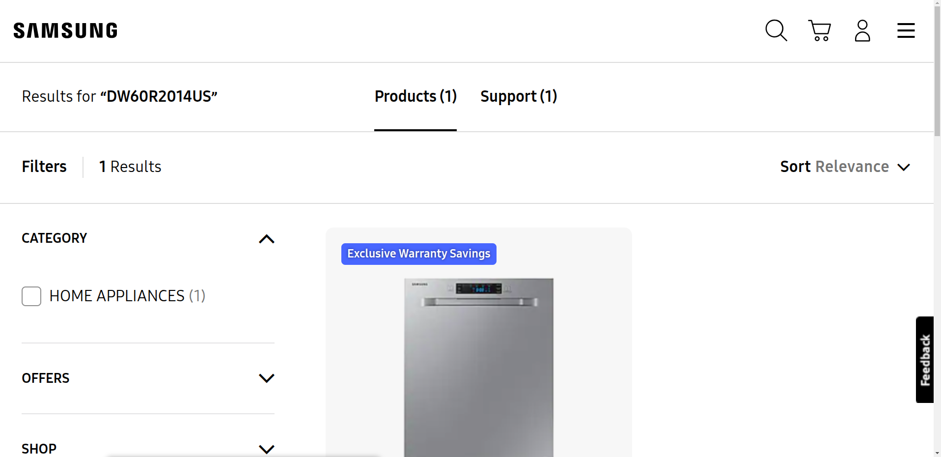

**Result :**

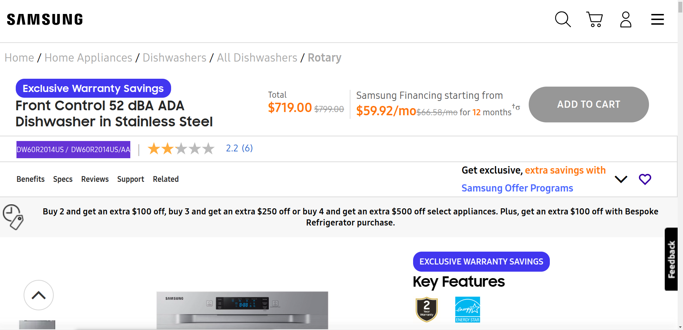

**Note: The mfr number is the same**

**Similar result products:**

* **Model name | mfr number**
* **RF261BEAESR/AA | RF261BEAESR/AA**
* **2 cu. ft. Counter Depth Side-by-Side Refrigerator | RS22T5201SR/AA**
* **H4500 LED Smart | UN24H4500AFXZA**
* **32 in Class M4500 HD TV | UN32M4500**
* **32 inch Class N5300 Smart Full HD TV | UN32N5300AFXZA**
* **32? Class Q60A QLED 4K Smart TV | QN32Q60AAFXZA**
* **40 inch Class NU7100 Smart 4K UHD TV | UN40NU7100FXZA**

**Response:**

**#02 - 43 inch 690 Series Direct-Lit LED Hospitality TV | HG43NF690GFXZA**

* **Using the model name as the search term**

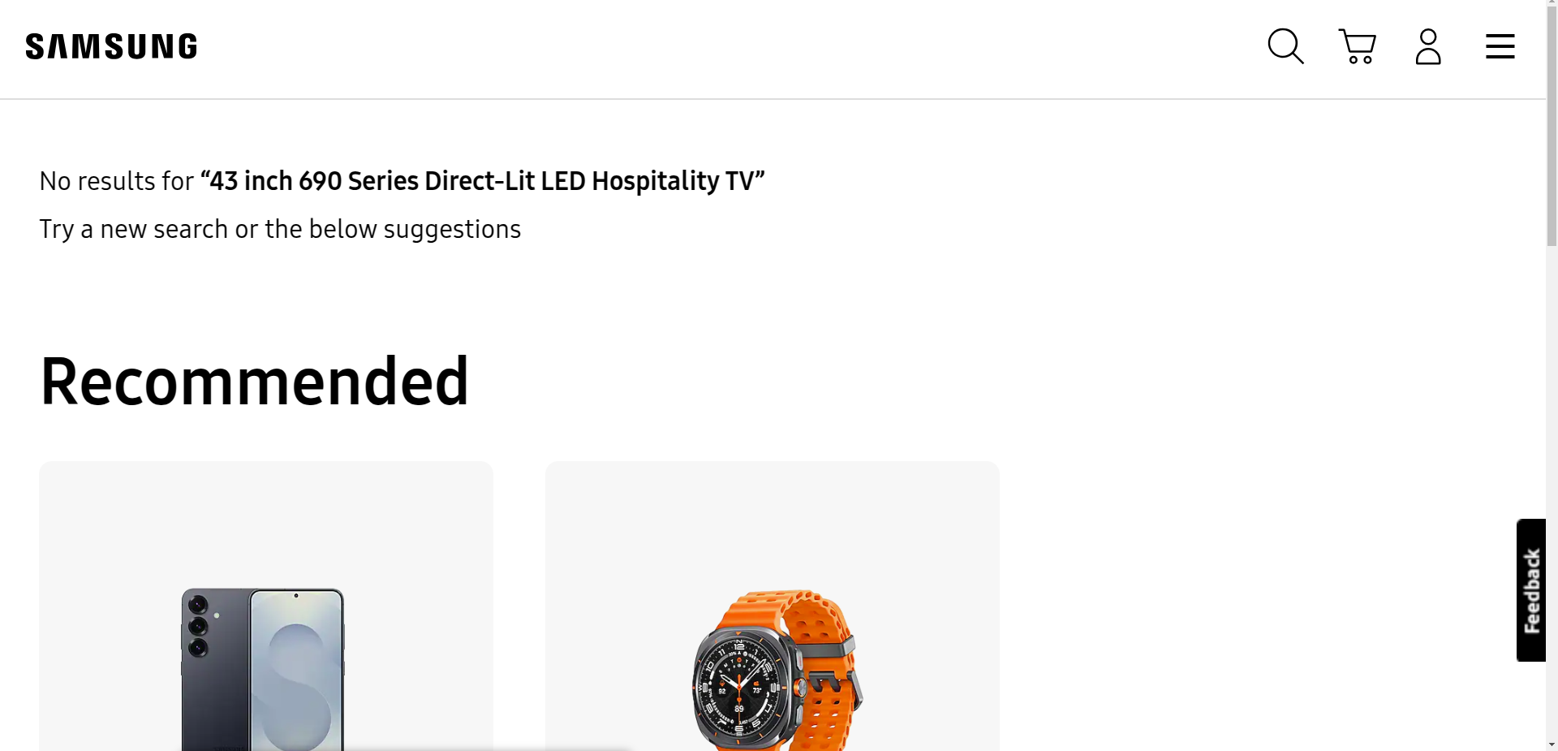

**Note: The two recommended products are identical across all missing products**

* **Using the mfr number as the search term**

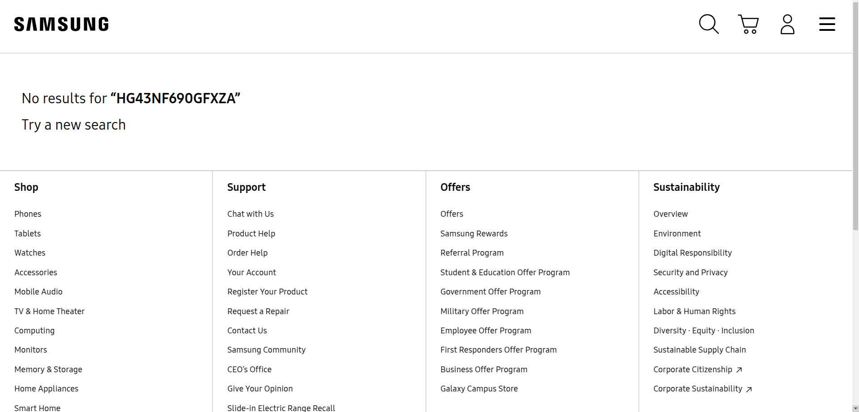

**Similar result products:**

* **Model name | mfr number**
* **Samsung 43'' 4K UHD QLED Smart TV, Hospi | HG43Q60AANFXZA-HC**
* **HG49NJ477MF | HG49NJ477MF**
* **OM46N - High Brightness Window Display (46 in.) | LH46OMNSLGB/ZA**
* **Samsung DC49J DCG Series 49 inch LED display | LH49DCJPLGA/GO**

**Response:**

**Note about product page:**

* **The mfr number is present on the product page. It is the same as the mfr number from the sheet but sometimes differs**

**Informations found on the page:**

* **model name**
* **price**
* **mfr number**
* **dimensions(width, height, depth)**
* **product image**
* **specifications pdf**
* **shipping weight**

**Missing : 31**

**Found : 81**

**Response:**